Git Repo Migration

git push --mirror [remote repo name]
git clone --mirror [repo remote url]
git remote set-url [remote repo name] [new repo remote url]

git push --mirror [remote repo name]
Bundled Repo
Mirrored Repo
Mirrored Repo
Big Picture
git clone --mirror [bundled repo location]
For network limitation situation, make repo bundled because it could be transferred by file base.
git bundle create [file name] --all
New Repo
Old Repo
Steps
- Clone existing repo with mirror option and change directory to mirror repo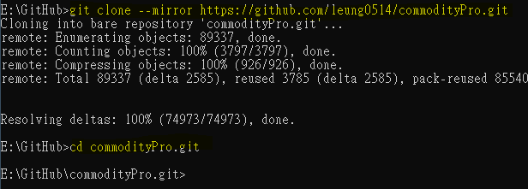Look for details https://git-scm.com/docs/git-clone#git-clone---mirror
- Check remote location and change them to new repo remote location 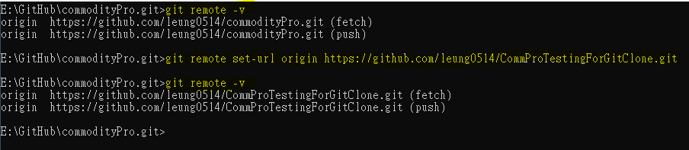
- (optional) Create bundled repo for this mirror repo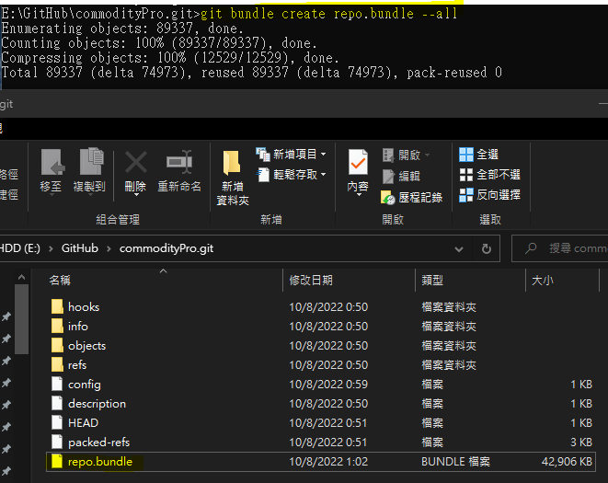
- Push to remote location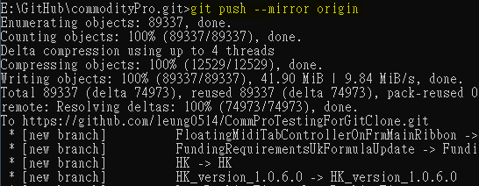
- Add new repo remote URL to GitHub Desktop App 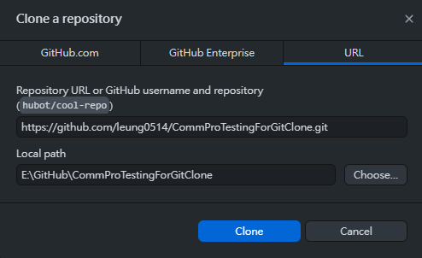
- For handle bundled repo, clone bundled repo with mirror option and change directory to mirror repo (I called it CommProRepoBundle here)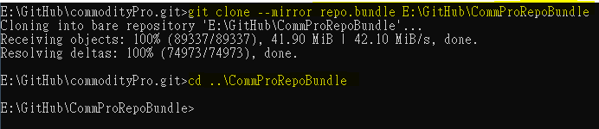
- Check remote location and change them to new repo remote location 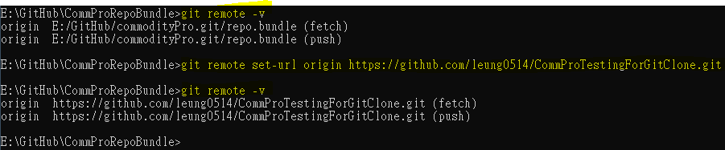
- Push to remote location same to step 4 and add to GitHub Desktop App same to step 5

